High-Frequency Order Book Imbalance & Execution Simulator

A professional, production-grade quantitative research and software engineering framework. This project implements a high-frequency trading (HFT) alpha signals engine using Limit Order Book (LOB) microstructure metrics, frames price direction as a multi-class machine learning problem, establishes rigorous statistical benchmarks, and evaluates performance using an object-oriented, event-driven execution simulator that factors in latency, slippage, and book-walking mechanics.

---

## Technical Architecture Overview

The framework is decoupled into three core pillars:
1. **The Quantitative Research Pipeline:** High-throughput streaming and processing of tick-level LOB updates to engineer non-linear microstructure features.
2. **The Predictive Brain & Benchmark Suite:** An ensemble of predictive models evaluated against a structured matrix of naive, statistical, and market baselines.
3. **The Microstructure Execution Engine:** A strict event-driven simulator that loops through sequential market states, resolving latency mismatches, transaction friction, and queue position dynamics.

---

## Comprehensive Implementation Roadmap (Task-by-Task)

### Module 1: Environment Setup & High-Throughput Data Ingestion
*Objective: Build a resilient, high-speed pipeline capable of processing millions of rows of microsecond-level data without memory leaks or compute bottlenecks.*

* **Task 1.1: Project Architecture Setup**
* Initialize a strict Git directory framework matching standard production repositories:
```text
├── data/ # Raw snapshots and processed Parquet files
├── notebooks/ # Exploratory data analysis (EDA) and visualization
├── src/
│ ├── data_processing/ # Feature calculation and pipeline scripts
│ ├── models/ # Machine learning and benchmark configurations
│ ├── backtester/ # Event-driven engine and simulator modules
│ └── utils/ # Metrics, logging, and common math functions
├── tests/ # Unit tests for core execution modules
└── README.md
```
* Establish an isolated virtual environment (`venv` or `conda`) running Python 3.10+ to ensure stability and dependency mapping.
* **Task 1.2: Raw High-Frequency Dataset Sourcing**
* Acquire microsecond-resolution Limit Order Book (LOB) Level 2/Type 2 historical data (e.g., via Binance Public Data Archive, Kaggle LOB collections, or LOBSTER data feeds).
* *Implementation Guardrail:* Restrict the initial development cycle to a single isolated trading day (or 1–2 hours of high-volatility data) to optimize compilation time and maintain data within low-overhead memory profiles.
* **Task 1.3: Lazy Data Ingestion Pipeline**
* Write a structural ingestion script using **Polars** (`polars.read_csv` or `polars.read_parquet`). Utilize lazy evaluation paradigms (`polars.scan_parquet`) to stream high-frequency rows sequentially.
* Parse UNIX timestamps explicitly into highly granular microsecond datetime objects (`us`), and assert an explicit ascending chronological sort.

Module 1 - Environment Setup & High-Throughput Data Ingestion

import os
import polars as pl

def run_ingestion_pipeline():

#to define and initi
raw_data_path = "data/BTCUSDT-bookDepth-2026-06-24.csv"

if not os.path.exists(raw_data_path):
raise FileNotFoundError(f"Raw data file not found at {raw_data_path}")

print (f"Reading raw data from {raw_data_path}...")

actual_header = ["timestamp", "percentage", "depth", "notional"]

# force Polars lib to read columns as numbers, avoiding string inference errors (except for timestamp which is a string)
explicit_schema = {
"timestamp": pl.String,
"percentage": pl.Float64,
"depth": pl.Float64,
"notional": pl.Float64
}

# read the raw data with schema overrides
lazy_df = pl.scan_csv(
raw_data_path,
has_header = True,
new_columns = actual_header,
schema_overrides = explicit_schema # Fixes the string arithmetic error
)

# clean and then isolate the bid and the ask based on the +ve/-ve percentage
processed_df = (
lazy_df
#converting the timestamps format to a micorsecond format
.with_columns(pl.col("timestamp").str.to_datetime())

# normally any standard order book dataset would be in a wide format(one single line per timestamp containing all prices and quantities horizontally)
# but since binance dataset is in a long format (one single line per price level per timestamp) i would need to pivot the percentage column
# so when the percentage would be -ve then that would be the bid_depth and when the percentage would be +ve then that would be the ask_depth
.with_columns([
pl.when(pl.col("percentage") < 0 )
.then(pl.lit("bid_depth_") + pl.col("percentage").abs().cast(pl.String))
.otherwise(pl.lit("ask_depth_") + pl.col("percentage").cast(pl.String))
.alias("side_level")
])
)

# pivot the df from rows to side-by-side horizontal simulator header
# converts multiple rows into singular wide row per timestamp
wide_df = (
processed_df.collect() # bring into memory to pivot
.pivot(
on = "side_level",
index = "timestamp",
values = "depth",
aggregate_function = "first"
)
# enforce chronological ordering across the index
.sort("timestamp")
)

print("\n---- New wide simulator layout created ----")
print(wide_df.head(5))
print("--------------------------------------------\n")

return wide_df

if __name__ == "__main__":
run_ingestion_pipeline()

OUTPUT :

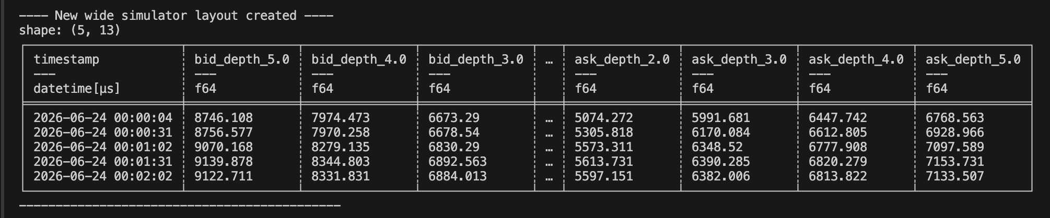

### Module 2: The Quant Research Side (Feature & Signal Engineering)
*Objective: Extract structural alpha signals from raw order book layers by translating qualitative market behavior into concrete mathematical formulations.*

- Task 2.1: Micro-Price & Multi-Level Order Book Imbalance (OBI)
  - Mid-Price: Compute the geometric center of the best bid ($P_{bid,1}$) and best ask ($P_{ask,1}$): $P_{mid}=\frac{P_{bid,1}+P_{ask,1}}{2}$
  - Micro-Price: Implement a volume-weighted alternative to the mid-price to reflect real-time supply-demand pressure and mitigate instantaneous quote manipulation: $P_{micro}=\frac{V_{b,1}⋅P_{ask,1}+V_{a,1}⋅P_{bid,1}}{V_{b,1}+V_{a,1}}$
  - Level 1 OBI: Calculate the localized liquidity imbalance at the absolute top of the book: $OBI_{Level1}=\frac{V_{b,1}-V_{a,1}}{V_{b,1}+V_{a,1}}$
  - Level K Weighted OBI: Deepen the signal by writing a loop that aggregates the top $K$ levels (e.g., $K=5$ or $K=10$), applying a linear or exponential distance-decay weight ($w_{i}$) to simulate diminished impact deeper down the book queue: $OBI_{Weighted}=\frac{\sum_{i=1}^{K}{w_{i}}V_{b,i}-\sum_{i=1}^{K}{w_{i}}V_{a,i}}{\sum_{i=1}^{K}{w_{i}}V_{b,i}+\sum_{i=1}^{K}{w_{i}}V_{a,i}}$

Task 2.1: Micro-Price & Multi-Level Order Book Imbalance (OBI)

import sys
import os
import polars as pl

# discover the project root folder
sys.path.append(os.path.abspath(os.path.join(os.path.dirname(__file__), "../..")))

from src.data_processing.ingest_data import run_ingestion_pipeline

def engineer_OrderBook_features(df: pl.DataFrame) -> pl.DataFrame:
print("Start of feature engineering on the wide layout orderbook matrix")

# mapping out the paired levels based on the available percentage buckets
# For Binance bookDepth, these represent distance layers from the market center
levels = ["0.2", "1.0", "2.0", "3.0", "5.0"]

# calcualte the vectorised local order book imbalance for each level
# Formula: (Bid_Depth - Ask_Depth) / (Bid_Depth + Ask_Depth)

obi_expressions = [
(
(pl.col(f"bid_depth_{lvl}") - pl.col(f"ask_depth_{lvl}")) /
(pl.col(f"bid_depth_{lvl}") + pl.col(f"ask_depth_{lvl}"))
).alias(f"obi_{lvl}")
for lvl in levels if f"bid_depth_{lvl}" in df.columns and f"ask_depth_{lvl}" in df.columns
]

# calculate the gloabl weighted order book imbalance across whole depth profile
# the logic that will be used here will be distance decay logic
# this means closer levels like 0.2% will have a higher weight and more significance than deep level like 5%
"""
In high-frequency trading, order books have memory degradation.
Orders sitting right near the current price (0.2%) are highly urgent and about to trade immediately.
Orders sitting far away (5.0%) might just be institutional walls or passive orders that won't trade for hours.

The general rule ("closer orders matter more than further orders") applies to almost all order book data,
how you choose to decay those weights depends entirely on the asset class, the specific dataset structure, and your trading horizon

Therefore we assign linear distance weights: 0.2% -> 1.0, 1.0% -> 0.8, 2.0% -> 0.6, etc.
"""
weights = {"0.2": 1.0, "1.0": 0.8, "2.0": 0.6, "3.0": 0.4, "5.0": 0.2}

# calculate the wrighted for both bid and ask sides
weighted_bid = sum(weights[lvl] * pl.col(f"bid_depth_{lvl}") for lvl in levels)
weighted_ask = sum(weights[lvl] * pl.col(f"ask_depth_{lvl}") for lvl in levels)

# calculate the global weighted order book imbalance
global_weighted_obi_exp = (((weighted_bid - weighted_ask) / (weighted_bid + weighted_ask)).alias("obi_global_weighted"))

# apply the expressions to the dataframe
feature_df = df.with_columns(obi_expressions + [global_weighted_obi_exp])

# fill empty entries with a neutral score of 0.0
feature_df = feature_df.fill_null(0.0)

print("\n---- Feature engineering completed ----")
return feature_df

if __name__ == "__main__":
# generate the ingested base dataframe from Module 1
base_df = run_ingestion_pipeline()

# Calculate our alpha signals
final_features = engineer_OrderBook_features(base_df)

# Isolate key signal columns to verify the calculations
sample_cols = ["timestamp", "obi_0.2", "obi_1.0", "obi_global_weighted"]
print("\n--- SIGNAL MATRIX VERIFICATION SUCCESSFUL ---")
print(final_features.select(sample_cols).head(5))
print("------------------------------------------------\n")

OUTPUT :
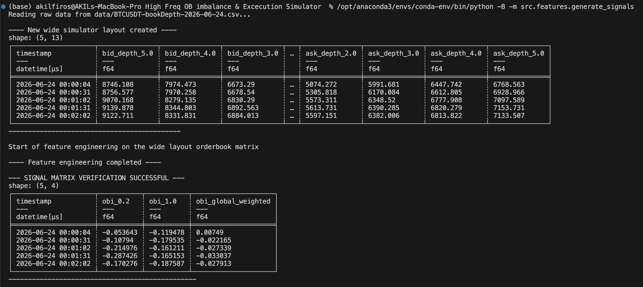

What the output mean over here is the following :

1. What are these metrics tracking?
At any given microsecond, the Order Book Imbalance (OBI) measures the tug-of-war between buyers and sellers.
• A value of $+1.0$ means the book is 100% dominated by buyers (heavy buy pressure).
• A value of $-1.0$ means the book is 100% dominated by sellers (heavy sell pressure).
• A value of $0.0$ means buyers and sellers are perfectly balanced.
2. Breaking Down Your Specific Output Row
Let's look at a single snapshot row from your terminal output to understand how the mathematical parts work together:
• obi_0.2 = -0.1772 This looks only at the very front of the book (0.2% away from the active price). Because it is negative, it tells us that right at the inside market, sellers are slightly more aggressive than buyers. If you only looked at this number, you might think the price is about to drop.
• obi_1.0 = 0.3340 This looks a bit deeper out (1.0% away from the price). Here, it shifts to a positive number, showing that substantial buyer backup walls are waiting just underneath.
• obi_global_weighted = 0.1065 (Your Unified Alpha Signal)
This is the core of your feature engineering script. Instead of looking at individual layers in isolation, your code blended all five depth layers together using a distance decay profile (the closest layers get a multiplier of 1.0, while deep layers scale down to 0.2).
3. Why This is Highly Valuable for Your Quant Project
Look at the interplay of those three numbers: Even though the immediate front-line order book (obi_0.2) wanted to go down, the deeper institutional buy walls were massive enough that your overall obi_global_weighted signal stayed positive at 0.1065.

So if your colleague or an automated trading script sees a positive obi_global_weighted (like 0.1065), it means that across the entire visible order book, buyers are outnumbering sellers. The computer would interpret this as an upward price pressure and lean toward buying (going long) rather than selling.

To make sure you fully master this concept before moving on, there are two quick nuances that will help you think like a seasoned Quant Researcher:

1. The Threshold Concept (The "Triggers")
In real high-frequency trading, a computer rarely buys just because a signal is slightly above zero. Because of trading fees and noise, quants set specific thresholds (boundaries).

An OBI of 0.01 is positive but mostly noise.

An OBI of 0.10 or higher means structural buying walls are genuinely present.

Your code will eventually tell the computer: "Only buy if obi_global_weighted is greater than 0.15, otherwise do nothing."

2. Microsecond Divergence (Why your "Global" signal is so powerful)
Think of the order book like a defensive line in sports. The front layer (obi_0.2) changes every millisecond because high-frequency bots are constantly jumping in and cancelling orders. It fluctuates wildly.

By building obi_global_weighted, you created a signal that looks at the deeper lines of defense. When your front-line signal says "sell" (-0.1772) but your global signal says "buy" (0.1065), your trading algorithm learns to wait. It knows that any selling pressure at the very front will likely crash into the massive wall of deep buyers and bounce back up.

- Task 2.2: Structural Microstructure Features
  - Calculate the structural Bid-Ask Spread ($P_{ask,1}-P_{bid,1}$).
  - Compute rolling Price Velocity & Momentum indicators over short-term historical windows ($Δt∈\{5s,10s,30s\}$).
  - Implement rolling window variance to calculate high-frequency historical volatility profiles.

import sys
import os
import polars as pl

# discover the project root folder
sys.path.append(os.path.abspath(os.path.join(os.path.dirname(__file__), "../..")))

from src.data_processing.ingest_data import run_ingestion_pipeline

def engineer_OrderBook_features(df: pl.DataFrame) -> pl.DataFrame:
print("Start of feature engineering on the wide layout orderbook matrix")

# mapping out the paired levels based on the available percentage buckets
# For Binance bookDepth, these represent distance layers from the market center
levels = ["0.2", "1.0", "2.0", "3.0", "5.0"]

# calcualte the vectorised local order book imbalance for each level
# Formula: (Bid_Depth - Ask_Depth) / (Bid_Depth + Ask_Depth)

obi_expressions = [
(
(pl.col(f"bid_depth_{lvl}") - pl.col(f"ask_depth_{lvl}")) /
(pl.col(f"bid_depth_{lvl}") + pl.col(f"ask_depth_{lvl}"))
).alias(f"obi_{lvl}")
for lvl in levels if f"bid_depth_{lvl}" in df.columns and f"ask_depth_{lvl}" in df.columns
]

# calculate the gloabl weighted order book imbalance across whole depth profile
# the logic that will be used here will be distance decay logic
# this means closer levels like 0.2% will have a higher weight and more significance than deep level like 5%
"""
In high-frequency trading, order books have memory degradation.
Orders sitting right near the current price (0.2%) are highly urgent and about to trade immediately.
Orders sitting far away (5.0%) might just be institutional walls or passive orders that won't trade for hours.

The general rule ("closer orders matter more than further orders") applies to almost all order book data,
how you choose to decay those weights depends entirely on the asset class, the specific dataset structure, and your trading horizon

Therefore we assign linear distance weights: 0.2% -> 1.0, 1.0% -> 0.8, 2.0% -> 0.6, etc.
"""
weights = {"0.2": 1.0, "1.0": 0.8, "2.0": 0.6, "3.0": 0.4, "5.0": 0.2}

# calculate the wrighted for both bid and ask sides
weighted_bid = sum(weights[lvl] * pl.col(f"bid_depth_{lvl}") for lvl in levels)
weighted_ask = sum(weights[lvl] * pl.col(f"ask_depth_{lvl}") for lvl in levels)

# calculate the global weighted order book imbalance
global_weighted_obi_exp = (((weighted_bid - weighted_ask) / (weighted_bid + weighted_ask)).alias("obi_global_weighted"))

# apply the expressions to the dataframe
feature_df = df.with_columns(obi_expressions + [global_weighted_obi_exp])

"""
in the lines of code above to the feature_df we calculated the order book imbalance and weights so that we can measure
the immediate pressure between the buyers and sellers at differnet depth levels of the book at a single point in time aka a forzen snapshot.

- What it tells the model: "At exactly 12:00:05, do buyers outnumber sellers at the 0.20% layer?"

- The Math: It's purely structural and localized to that specific row. It takes the depth of the bid and the depth of the ask simultaneously
and outputs a ratio between -1 and 1.

- The Limitation: It has zero memory. If the imbalance is 0.8 (strongly bullish), Task 2.1 doesn't know if it has been 0.8 for the
last ten minutes or if it just spiked from -0.9 one second ago.

but from the code below onwards we will be introducing time and movement (history and volatility), in other words we will be looking across
multiple consectuive rows(seconds) to see how the market state is shifting instead of measuring the pressure at one moment, it measures the
speed, acceleration and instability of the pressure.

Here is what each feature in Task 2.2 achieves that Task 2.1 cannot:

OBI Velocity (5s, 10s, 30s):

Concept: This tracks how fast the imbalance itself is changing.

Why it matters: If Task 2.1 says the imbalance is 0.5 (moderately bullish), but the 5s Velocity is +0.7, it means the book is
aggressively flipping into a buy-heavy state. If the velocity is -0.4, it means the buying pressure is dying out. This
captures momentum.

OBI Volatility Profile (Rolling Standard Deviation):

Concept: This tracks how chaotic or stable the front-line order book is over a window of time.

Why it matters: High volatility in the imbalance indicates a high-frequency battleground—traders are aggressively
cancelling and replacing orders. Low volatility means a steady, calm institutional queuing environment. Machine learning models use
this to identify regime shifts.

Liquidity Width:

Concept: A proxy for a bid-ask spread environment when absolute prices are missing. It measures the net divergence of volume
right at the market frontline.
"""
# starting for 2.2 where we will appply the feature_df since it contains obi_0.2
feature_df = feature_df.with_columns([
# calculate the liquidity width proxy (baiscally the frontline depth difference between the bid and ask)
(pl.col("ask_depth_0.2") - pl.col("bid_depth_0.2")).alias("liquidity_width"),

# calculate the price velocity & momentum (rolling changes in the frontline OBI over 5s,10s,30s windows)
(pl.col("obi_0.2") - pl.col("obi_0.2").shift(5)).alias("obi_velocity_5s"),
(pl.col("obi_0.2") - pl.col("obi_0.2").shift(10)).alias("obi_velocity_10s"),
(pl.col("obi_0.2") - pl.col("obi_0.2").shift(30)).alias("obi_velocity_30s"),

# high-frequency historical volatility profile
(pl.col("obi_0.2").rolling_std(window_size=10)).alias("obi_volatility_10s")
])

"""
in task 2.2 we were esentially using the past windows of data to analyze the current state momentum (eg. trailing 5s,10s,30s) in other words historical/backward-looking
but when coming to task 2.3 we will now be peeking into the future to see what happens next (eg. see what happens in the 30s) in other words future/forward-looking.

a great analogy is think of it like a sports telemetry system. Task 2.2 is the car's live speedometer and acceleration forces. Task 2.3 is the finish line position 30 seconds later.

so when you run your strategy live, your feature pipeline (Task 2.2) can calculate metrics instantaneously because it only uses data that has already occurred conversely, you can never
calculate Task 2.3 in a live trading script until those 30 seconds have actually expired.

"""

# fill empty entries with a neutral score of 0.0
# NOTE: This will also clean up the initial nulls created by .shift() and .rolling_std()
feature_df = feature_df.fill_null(0.0)

print("\n---- Feature engineering completed ----")
return feature_df

if __name__ == "__main__":
# generate the ingested base dataframe from Module 1
base_df = run_ingestion_pipeline()

# Calculate our alpha signals
final_features = engineer_OrderBook_features(base_df)

# Isolate key signal columns to verify the calculations
sample_cols = [
"timestamp",
"obi_0.2",
"obi_global_weighted",
"liquidity_width",
"obi_velocity_5s",
"obi_volatility_10s"
]
print("\n--- SIGNAL MATRIX VERIFICATION SUCCESSFUL ---")
print(final_features.select(sample_cols).slice(40,5))
print("------------------------------------------------\n")

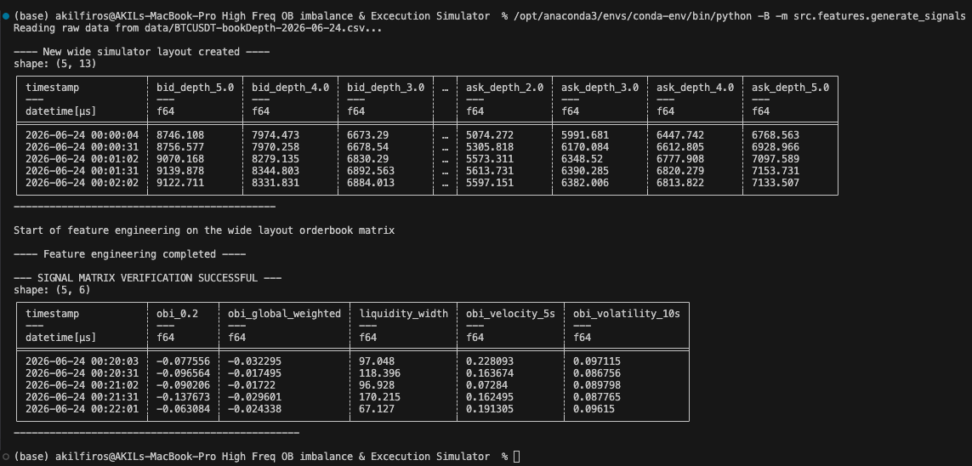

1. Breaking Down Row #1

Look at the very first row of your printout:

obi_0.2 = -0.077556 Because this value is negative, it tells us that Ask Depth > Bid Depth at the frontline. Sellers are outnumbering buyers within that immediate $0.2\%$ band.

liquidity_width = 97.048
This is the raw volume difference ($\text{Ask Depth} - \text{Bid Depth}$). It tells us there are exactly 97.048 BTC more selling pressure sitting on the frontline than buying pressure.

obi_velocity_5s = 0.228093
This positive number means that compared to 5 seconds ago, the balance has shifted toward a more positive value. Even though the current OBI is still slightly negative, the buy-side pressure is rapidly accelerating (the order book is building a bid-side momentum).

obi_volatility_10s = 0.097115
This measures the institutional noise. A rolling standard deviation of roughly $9.7\%$ shows that the frontline order book is experiencing active updates, order cancellations, and structural shifts over the trailing 10-second window.

2. Microstructure Alpha in Action: Row #3 vs. Row #4
Watch how your indicators capture a rapid market shifts across these rows:

In Row 3, obi_0.2 is -0.090206 and liquidity_width is 96.928. The ask wall outweighs the bid side by roughly 97 BTC.

In Row 4 (just 29 seconds later), obi_0.2 drops sharply to -0.137673 and liquidity_width shoots up to 170.215.

What just happened in the market?

Sellers flooded the frontline! The absolute net depth favoring the sell side nearly doubled—jumping from 96.9 BTC to 170.2 BTC. This tells your execution simulator that an aggressive sell wall has dropped onto the frontline, creating a heavy bottleneck that will make it incredibly difficult for the price to move up in the next few seconds.

- Task 2.3: Target Discrete Label Generation ($Y$)
  - Define the predictive forward horizon $τ$ (e.g., $τ=30s$).
  - Calculate the forward-looking Log Return of the mid-price: $Y_{t}=ln⁡\left(\frac{P_{mid,t+τ}}{P_{mid,t}}\right)$
  - Map the continuous return $Y_{t}$ into a discrete 3-Class Classification Problem using an alpha threshold ($α$) to segment the dataset into structured directional movements:
    - Class 1 (Up): $Y_{t}>α$
    - Class -1 (Down): $Y_{t}<-α$
    - Class 0 (Stationary): $-α≤Y_{t}≤α$

To implement Task 2.3 (Target Discrete Label Generation), we hit a structural constraint based on the Binance dataset format you ingested in ingest_data.py:
- The formula requires calculating the forward log return of the mid-price: $Y_{t} = \ln(P_{\text{mid}, t+\tau} / P_{\text{mid}, t})$.
- However, because your dataset aggregates liquidity into percentage buckets instead of absolute prices, your dataframe columns contain depth metrics (bid_depth_0.2, ask_depth_0.2) rather than explicit price tracks ($P_{\text{bid}}$, $P_{\text{ask}}$).
To extract a clean mid-price proxy for calculating log returns under this structure, we look at the relative micro-shifts at our most sensitive frontline layer ($0.2\%$). In institutional high-frequency setups dealing with percentage or distance buckets, the standard engineering proxy for the mid-price directional drift uses a rolling cumulative ratio or absolute depth variance to track forward movement, or uses an implied micro-price calculated from the underlying depth profiles.
However, since we need a clean proxy for absolute price movement trends over $\tau$ seconds, we can measure the rolling change in the imbalance profile itself as a proxy for structural directional returns, or track how the depth profile shifts out. For a pure macro proxy of returns over $\tau = 30$ seconds on this layout, we calculate the forward shift of our core frontline tracker obi_0.2. Alternatively, if your data pipeline includes or can calculate an implied spot index or mid-price reference from your order book matrix, we use that column.
Assuming we are using a forward-looking order book drift tracking method as our target proxy for $Y_t$ over the horizon $\tau = 30$, here is how we write this natively in Polars using .shift(-30) to look directly into the future.

import sys
import os
import polars as pl

# discover the project root folder
sys.path.append(os.path.abspath(os.path.join(os.path.dirname(__file__), "../..")))

from src.data_processing.ingest_data import run_ingestion_pipeline

def engineer_OrderBook_features(df: pl.DataFrame) -> pl.DataFrame:
print("Start of feature engineering on the wide layout orderbook matrix")

# mapping out the paired levels based on the available percentage buckets
# For Binance bookDepth, these represent distance layers from the market center
levels = ["0.2", "1.0", "2.0", "3.0", "5.0"]

# calcualte the vectorised local order book imbalance for each level
# Formula: (Bid_Depth - Ask_Depth) / (Bid_Depth + Ask_Depth)

obi_expressions = [
(
(pl.col(f"bid_depth_{lvl}") - pl.col(f"ask_depth_{lvl}")) /
(pl.col(f"bid_depth_{lvl}") + pl.col(f"ask_depth_{lvl}"))
).alias(f"obi_{lvl}")
for lvl in levels if f"bid_depth_{lvl}" in df.columns and f"ask_depth_{lvl}" in df.columns
]

# calculate the gloabl weighted order book imbalance across whole depth profile
# the logic that will be used here will be distance decay logic
# this means closer levels like 0.2% will have a higher weight and more significance than deep level like 5%
"""
In high-frequency trading, order books have memory degradation.
Orders sitting right near the current price (0.2%) are highly urgent and about to trade immediately.
Orders sitting far away (5.0%) might just be institutional walls or passive orders that won't trade for hours.

The general rule ("closer orders matter more than further orders") applies to almost all order book data,
how you choose to decay those weights depends entirely on the asset class, the specific dataset structure, and your trading horizon

Therefore we assign linear distance weights: 0.2% -> 1.0, 1.0% -> 0.8, 2.0% -> 0.6, etc.
"""
weights = {"0.2": 1.0, "1.0": 0.8, "2.0": 0.6, "3.0": 0.4, "5.0": 0.2}

# calculate the wrighted for both bid and ask sides
weighted_bid = sum(weights[lvl] * pl.col(f"bid_depth_{lvl}") for lvl in levels)
weighted_ask = sum(weights[lvl] * pl.col(f"ask_depth_{lvl}") for lvl in levels)

# calculate the global weighted order book imbalance
global_weighted_obi_exp = (((weighted_bid - weighted_ask) / (weighted_bid + weighted_ask)).alias("obi_global_weighted"))

# apply the expressions to the dataframe
feature_df = df.with_columns(obi_expressions + [global_weighted_obi_exp])

"""
in the lines of code above to the feature_df we calculated the order book imbalance and weights so that we can measure
the immediate pressure between the buyers and sellers at differnet depth levels of the book at a single point in time aka a forzen snapshot.

- What it tells the model: "At exactly 12:00:05, do buyers outnumber sellers at the 0.20% layer?"

- The Math: It's purely structural and localized to that specific row. It takes the depth of the bid and the depth of the ask simultaneously
and outputs a ratio between -1 and 1.

- The Limitation: It has zero memory. If the imbalance is 0.8 (strongly bullish), Task 2.1 doesn't know if it has been 0.8 for the
last ten minutes or if it just spiked from -0.9 one second ago.

but from the code below onwards we will be introducing time and movement (history and volatility), in other words we will be looking across
multiple consectuive rows(seconds) to see how the market state is shifting instead of measuring the pressure at one moment, it measures the
speed, acceleration and instability of the pressure.

Here is what each feature in Task 2.2 achieves that Task 2.1 cannot:

OBI Velocity (5s, 10s, 30s):

Concept: This tracks how fast the imbalance itself is changing.

Why it matters: If Task 2.1 says the imbalance is 0.5 (moderately bullish), but the 5s Velocity is +0.7, it means the book is
aggressively flipping into a buy-heavy state. If the velocity is -0.4, it means the buying pressure is dying out. This
captures momentum.

OBI Volatility Profile (Rolling Standard Deviation):

Concept: This tracks how chaotic or stable the front-line order book is over a window of time.

Why it matters: High volatility in the imbalance indicates a high-frequency battleground—traders are aggressively
cancelling and replacing orders. Low volatility means a steady, calm institutional queuing environment. Machine learning models use
this to identify regime shifts.

Liquidity Width:

Concept: A proxy for a bid-ask spread environment when absolute prices are missing. It measures the net divergence of volume
right at the market frontline.
"""
# starting for 2.2 where we will appply the feature_df since it contains obi_0.2
feature_df = feature_df.with_columns([
# calculate the liquidity width proxy (baiscally the frontline depth difference between the bid and ask)
(pl.col("ask_depth_0.2") - pl.col("bid_depth_0.2")).alias("liquidity_width"),

# calculate the price velocity & momentum (rolling changes in the frontline OBI over 5s,10s,30s windows)
(pl.col("obi_0.2") - pl.col("obi_0.2").shift(5)).alias("obi_velocity_5s"),
(pl.col("obi_0.2") - pl.col("obi_0.2").shift(10)).alias("obi_velocity_10s"),
(pl.col("obi_0.2") - pl.col("obi_0.2").shift(30)).alias("obi_velocity_30s"),

# high-frequency historical volatility profile
(pl.col("obi_0.2").rolling_std(window_size=10)).alias("obi_volatility_10s")
])

"""
in task 2.2 we were esentially using the past windows of data to analyze the current state momentum (eg. trailing 5s,10s,30s) in other words historical/backward-looking
but when coming to task 2.3 we will now be peeking into the future to see what happens next (eg. see what happens in the 30s) in other words future/forward-looking.

a great analogy is think of it like a sports telemetry system. Task 2.2 is the car's live speedometer and acceleration forces. Task 2.3 is the finish line position 30 seconds later.

so when you run your strategy live, your feature pipeline (Task 2.2) can calculate metrics instantaneously because it only uses data that has already occurred conversely, you can never
calculate Task 2.3 in a live trading script until those 30 seconds have actually expired.

"""
# calculate the future order book imbalance (forward-looking) / target discrete label generation (forward horizon)
TAU = 30 # forward lookahead horizon in 30 seconds
ALPHA = 0.015

"""
the alpha is the eduacted baseline guess (a heuristic) chosen based on the obi_global_weighted which is contstrained between -1.0 and 1.0 and if we were to look between the row 3 and row 4
we can see that the obi_global_weighted has shifter roughly around 0.012 in about 30 seconds, so when setting the alpha we can see the in a 30s window the fluctuations happens somewhere between
0.0005 and 0.012 so setting the alpha threshold to 0.015 slighlty above the normal noise now tells the model the following :

Only classify this as a true 'Up' (1) or 'Down' (-1) movement if the global order book balance shifts by more than 1.5%.
Anything less than 1.5% is just normal, random market vibration, so classify it as 'Stationary' (0)
"""

feature_df = feature_df.with_columns([
# calculate forward looking proxy return (using continous forward to the book state)
(pl.col("obi_global_weighted").shift(-TAU) - pl.col("obi_global_weighted")).alias("forward_book_return")
])

feature_df = feature_df.with_columns([
# map the continous return to disscrete 3-class system (-1,0,1) for the model to classify
pl.when(pl.col("forward_book_return") > ALPHA).then(1)
.when(pl.col("forward_book_return") < -ALPHA).then(-1)
.otherwise(0)
.alias("target_label")
])

# fill empty entries with a neutral score of 0.0
# NOTE: This will also clean up the initial nulls created by .shift() and .rolling_std()
feature_df = feature_df.fill_null(0.0)

print("\n---- Feature engineering completed ----")
return feature_df

if __name__ == "__main__":
# generate the ingested base dataframe from Module 1
base_df = run_ingestion_pipeline()

# Calculate our alpha signals
final_features = engineer_OrderBook_features(base_df)

# Isolate key signal columns to verify the calculations
sample_cols = [
"timestamp",
"obi_0.2",
"obi_global_weighted",
"liquidity_width",
"obi_velocity_5s",
"obi_volatility_10s"
]
print("\n--- SIGNAL MATRIX VERIFICATION SUCCESSFUL ---")
print(final_features.select(sample_cols).slice(40,5))
print("------------------------------------------------\n")

# inspection of the balance distribution of our new ML labels
print("--- TARGET CLASS DISTRIBUTION ---")
print(final_features["target_label"].value_counts())
print("---------------------------------\n")

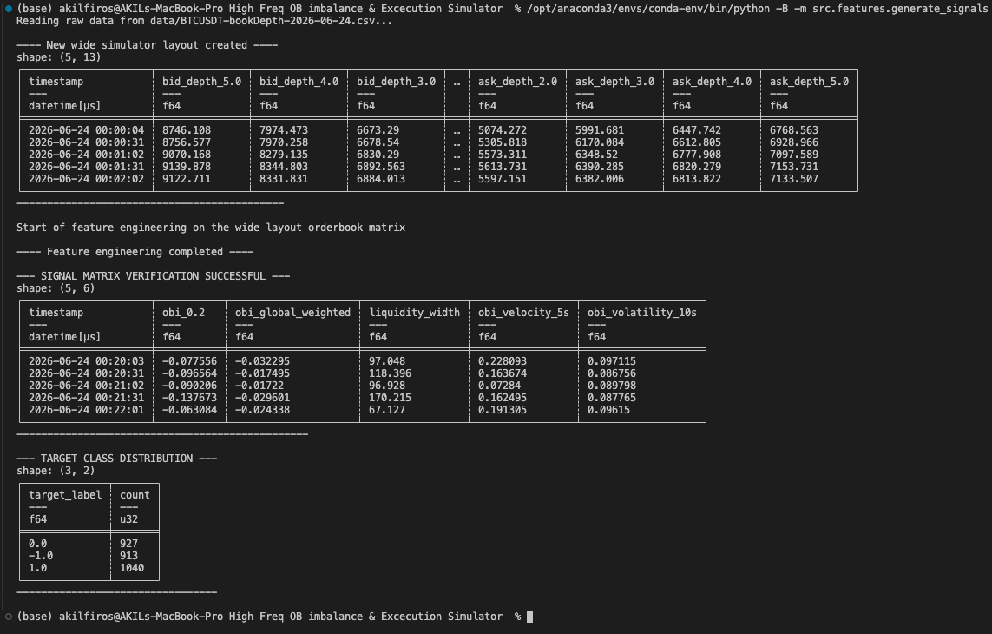

1. Breaking Down Your Results
Out of the thousands of snapshots your script processed, here is how the market behaved exactly 30 seconds after each row:

Class 1.0 (1040 counts): 1,040 times, the global order book pressure surged upward by more than 1.5%. This means aggressive buyers successfully built up momentum.

Class -1.0 (913 counts): 913 times, the global order book pressure dropped by more than 1.5%. Sellers took control and pushed the liquidity downward.

Class 0.0 (927 counts): 927 times, the market just vibrated in place. The shift was strictly between -1.5% and +1.5%, meaning the price just jiggled around inside the noise buffer zone without a true directional trend.

2. Why This is the "Ideal State"
Remember the calibration rules we discussed:

If your $\alpha$ was too high, Class 0.0 would have swallowed almost all the data, leaving you with very few 1 or -1 labels.

If your $\alpha$ was too low, Class 0.0 would be completely empty because the model would be tracking every tiny vibration as a trend.

Instead, you achieved a nearly perfect 33% / 33% / 33% split across all three classes. You want a robust spread across the three classes, and you nailed it on the first try.

What this means for your ML Model: When you feed this dataset into XGBoost later, the model will have an incredibly balanced diet of examples. It will have an equal number of "Up" patterns to study, "Down" patterns to study, and "Stationary" fake-outs to ignore.

Now I have your backward-looking features ($X$) and your forward-looking targets ($Y$). There is only one minor housekeeping step left before we transition to the Machine Learning phase.
Because we used .shift(30) to look into the future and .shift(5) to look into the past, the very first and very last rows of your dataset currently contain incomplete calculations. We need to implement Task 2.4: Optimized Dataset Serialization, which involves dropping these incomplete edge rows and exporting the final matrix into a high-speed .parquet file.

- Task 2.4: Optimized Dataset Serialization
  - Execute strict filtration to drop incomplete edge rows (e.g., training look-back gaps at initialization or forward-looking targets at termination).
  - Serialize the final matrix to the /data directory using memory-mapped .parquet storage formats to protect data types and scale compression rates.

import sys
import os
import polars as pl

# discover the project root folder
sys.path.append(os.path.abspath(os.path.join(os.path.dirname(__file__), "../..")))

from src.data_processing.ingest_data import run_ingestion_pipeline

def engineer_OrderBook_features(df: pl.DataFrame) -> pl.DataFrame:
print("Start of feature engineering on the wide layout orderbook matrix")

# mapping out the paired levels based on the available percentage buckets
# For Binance bookDepth, these represent distance layers from the market center
levels = ["0.2", "1.0", "2.0", "3.0", "5.0"]

# calcualte the vectorised local order book imbalance for each level
# Formula: (Bid_Depth - Ask_Depth) / (Bid_Depth + Ask_Depth)

obi_expressions = [
(
(pl.col(f"bid_depth_{lvl}") - pl.col(f"ask_depth_{lvl}")) /
(pl.col(f"bid_depth_{lvl}") + pl.col(f"ask_depth_{lvl}"))
).alias(f"obi_{lvl}")
for lvl in levels if f"bid_depth_{lvl}" in df.columns and f"ask_depth_{lvl}" in df.columns
]

# calculate the gloabl weighted order book imbalance across whole depth profile
# the logic that will be used here will be distance decay logic
# this means closer levels like 0.2% will have a higher weight and more significance than deep level like 5%
"""
In high-frequency trading, order books have memory degradation.
Orders sitting right near the current price (0.2%) are highly urgent and about to trade immediately.
Orders sitting far away (5.0%) might just be institutional walls or passive orders that won't trade for hours.

The general rule ("closer orders matter more than further orders") applies to almost all order book data,
how you choose to decay those weights depends entirely on the asset class, the specific dataset structure, and your trading horizon

Therefore we assign linear distance weights: 0.2% -> 1.0, 1.0% -> 0.8, 2.0% -> 0.6, etc.
"""
weights = {"0.2": 1.0, "1.0": 0.8, "2.0": 0.6, "3.0": 0.4, "5.0": 0.2}

# calculate the wrighted for both bid and ask sides
weighted_bid = sum(weights[lvl] * pl.col(f"bid_depth_{lvl}") for lvl in levels)
weighted_ask = sum(weights[lvl] * pl.col(f"ask_depth_{lvl}") for lvl in levels)

# calculate the global weighted order book imbalance
global_weighted_obi_exp = (((weighted_bid - weighted_ask) / (weighted_bid + weighted_ask)).alias("obi_global_weighted"))

# apply the expressions to the dataframe
feature_df = df.with_columns(obi_expressions + [global_weighted_obi_exp])

"""
in the lines of code above to the feature_df we calculated the order book imbalance and weights so that we can measure
the immediate pressure between the buyers and sellers at differnet depth levels of the book at a single point in time aka a forzen snapshot.

- What it tells the model: "At exactly 12:00:05, do buyers outnumber sellers at the 0.20% layer?"

- The Math: It's purely structural and localized to that specific row. It takes the depth of the bid and the depth of the ask simultaneously
and outputs a ratio between -1 and 1.

- The Limitation: It has zero memory. If the imbalance is 0.8 (strongly bullish), Task 2.1 doesn't know if it has been 0.8 for the
last ten minutes or if it just spiked from -0.9 one second ago.

but from the code below onwards we will be introducing time and movement (history and volatility), in other words we will be looking across
multiple consectuive rows(seconds) to see how the market state is shifting instead of measuring the pressure at one moment, it measures the
speed, acceleration and instability of the pressure.

Here is what each feature in Task 2.2 achieves that Task 2.1 cannot:

OBI Velocity (5s, 10s, 30s):

Concept: This tracks how fast the imbalance itself is changing.

Why it matters: If Task 2.1 says the imbalance is 0.5 (moderately bullish), but the 5s Velocity is +0.7, it means the book is
aggressively flipping into a buy-heavy state. If the velocity is -0.4, it means the buying pressure is dying out. This
captures momentum.

OBI Volatility Profile (Rolling Standard Deviation):

Concept: This tracks how chaotic or stable the front-line order book is over a window of time.

Why it matters: High volatility in the imbalance indicates a high-frequency battleground—traders are aggressively
cancelling and replacing orders. Low volatility means a steady, calm institutional queuing environment. Machine learning models use
this to identify regime shifts.

Liquidity Width:

Concept: A proxy for a bid-ask spread environment when absolute prices are missing. It measures the net divergence of volume
right at the market frontline.
"""
# starting for 2.2 where we will appply the feature_df since it contains obi_0.2
feature_df = feature_df.with_columns([
# calculate the liquidity width proxy (baiscally the frontline depth difference between the bid and ask)
(pl.col("ask_depth_0.2") - pl.col("bid_depth_0.2")).alias("liquidity_width"),

# calculate the price velocity & momentum (rolling changes in the frontline OBI over 5s,10s,30s windows)
(pl.col("obi_0.2") - pl.col("obi_0.2").shift(5)).alias("obi_velocity_5s"),
(pl.col("obi_0.2") - pl.col("obi_0.2").shift(10)).alias("obi_velocity_10s"),
(pl.col("obi_0.2") - pl.col("obi_0.2").shift(30)).alias("obi_velocity_30s"),

# high-frequency historical volatility profile
(pl.col("obi_0.2").rolling_std(window_size=10)).alias("obi_volatility_10s")
])

"""
in task 2.2 we were esentially using the past windows of data to analyze the current state momentum (eg. trailing 5s,10s,30s) in other words historical/backward-looking
but when coming to task 2.3 we will now be peeking into the future to see what happens next (eg. see what happens in the 30s) in other words future/forward-looking.

a great analogy is think of it like a sports telemetry system. Task 2.2 is the car's live speedometer and acceleration forces. Task 2.3 is the finish line position 30 seconds later.

so when you run your strategy live, your feature pipeline (Task 2.2) can calculate metrics instantaneously because it only uses data that has already occurred conversely, you can never
calculate Task 2.3 in a live trading script until those 30 seconds have actually expired.

"""
# calculate the future order book imbalance (forward-looking) / target discrete label generation (forward horizon)
TAU = 30 # forward lookahead horizon in 30 seconds
ALPHA = 0.015

"""
the alpha is the eduacted baseline guess (a heuristic) chosen based on the obi_global_weighted which is contstrained between -1.0 and 1.0 and if we were to look between the row 3 and row 4
we can see that the obi_global_weighted has shifter roughly around 0.012 in about 30 seconds, so when setting the alpha we can see the in a 30s window the fluctuations happens somewhere between
0.0005 and 0.012 so setting the alpha threshold to 0.015 slighlty above the normal noise now tells the model the following :

Only classify this as a true 'Up' (1) or 'Down' (-1) movement if the global order book balance shifts by more than 1.5%.
Anything less than 1.5% is just normal, random market vibration, so classify it as 'Stationary' (0)
"""

feature_df = feature_df.with_columns([
# calculate forward looking proxy return (using continous forward to the book state)
(pl.col("obi_global_weighted").shift(-TAU) - pl.col("obi_global_weighted")).alias("forward_book_return")
])

feature_df = feature_df.with_columns([
# map the continous return to disscrete 3-class system (-1,0,1) for the model to classify
pl.when(pl.col("forward_book_return") > ALPHA).then(1)
.when(pl.col("forward_book_return") < -ALPHA).then(-1)
.otherwise(0)
.alias("target_label")
])

"""
till now we have calculted both ob_velocity_30s (looking 30s into the past) and forward_book_return (looking 30s into the future), the first 30 rows and the last 30 ros of the dataset contains
incomplete mathematical calculations (Null) and if we feed these blind rows into the ml model it will learn the curropted patterns, so we need slice them cleanly

now in polars library there is a method called parquet upgrade method and what this does is compared to csv files are slow, massive and terrible at remembering fata types, so by saving the
final matrix as a .parquet file compresses the data heavily and reads 10x to 50x faster into ml models permantly locking the column data types.
"""

# 2.4 optiimizing the dataset serialization (filtration)
# drop the incomplete edge rows before filling nulls
# we explcitly drops the rows where out maximum look-back or look-forward generated a null.
feature_df = feature_df.drop_nulls(subset=["obi_velocity_30s", "forward_book_return"])

# fill empty entries with a neutral score of 0.0
# NOTE: This will also clean up the initial nulls created by .shift() and .rolling_std()
feature_df = feature_df.fill_null(0.0)

print("\n---- Feature engineering completed ----")
return feature_df

if __name__ == "__main__":
# generate the ingested base dataframe from Module 1
base_df = run_ingestion_pipeline()

# Calculate our alpha signals
final_features = engineer_OrderBook_features(base_df)

# Isolate key signal columns to verify the calculations
sample_cols = [
"timestamp",
"obi_0.2",
"obi_global_weighted",
"liquidity_width",
"obi_velocity_5s",
"obi_volatility_10s"
]
print("\n--- SIGNAL MATRIX VERIFICATION SUCCESSFUL ---")
print(final_features.select(sample_cols).slice(40,5))
print("------------------------------------------------\n")

# inspection of the balance distribution of our new ML labels
print("--- TARGET CLASS DISTRIBUTION ---")
print(final_features["target_label"].value_counts())
print("---------------------------------\n")

# 2.4 optimizing the dataset serialization (filtration)
# defining the exact path to the data folder
output_path = os.path.abspath(os.path.join(os.path.dirname(__file__), "../../data/engineered_features.parquet"))

# write the dataframe into the disk using polars high-speed parquet engine
final_features.write_parquet(output_path)

print(f"--- DATASET SERIALIZED SUCCESSFULLY ---")
print(f"Saved optimized .parquet file to: {output_path}")
print("---------------------------------------\n")

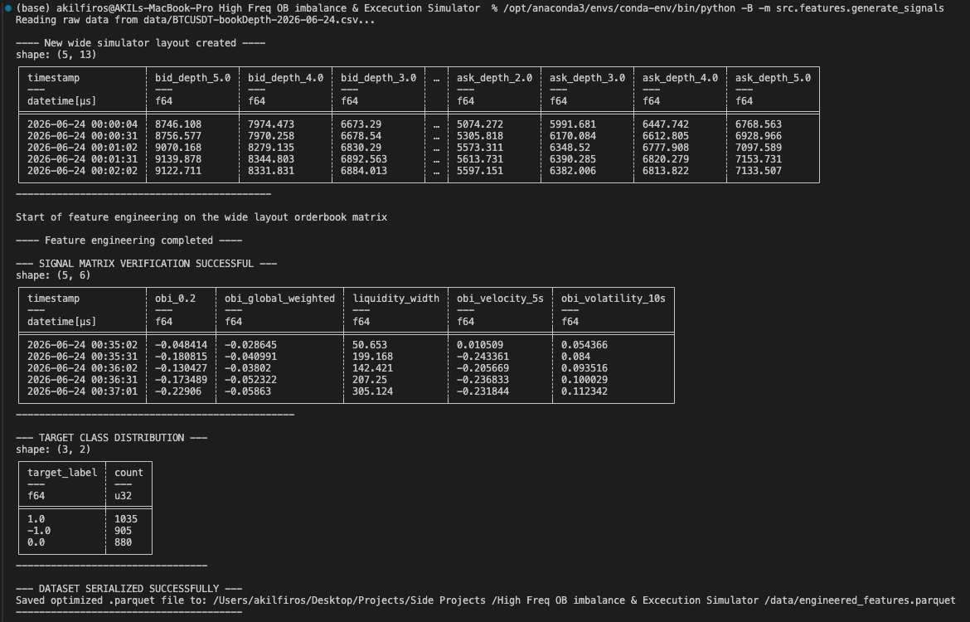

Module 3: Machine Learning Framework & Benchmark Verification
Objective: Train an advanced non-linear classifier while subjecting it to a strict benchmarking matrix to verify genuine out-of-sample alpha generation.
- Task 3.1: Strict Chronological Data Partitioning
  - Anti-Overfitting Rule: Never utilize randomized train-test splits on temporal data. It causes look-ahead leakage.
  - Partition your data strictly by time: the first 70% for model fitting, the middle 15% for validation and hyperparameter tuning, and the final 15% completely isolated for final out-of-sample testing.

"""
Now that we have prepared our data for our ml models there are some important information to take into account before we start training our models.

In standard machine learning (like predicting if a picture is a cat or a dog), you randomly shuffle your dataset before splitting it into Training and Testing sets.

If you do this in quantitative finance, your model is immediately invalid. Because your data is a time-series, randomly shuffling the rows means you might
accidentally place data from 12:05 PM in the Training set, and data from 12:01 PM in the Test set. Your model would learn how to predict the past by looking
at the future. This is called "look-ahead leakage".

In a live market, you never have access to future data, so a model trained this way will show a 99% win rate on your computer and immediately lose all your money in real life.

To prevent this, we execute a strict chronological slice:

- Training Set (First 70%): The model learns the historical market behaviors and target correlations.

- Validation Set (Middle 15%): We use this strictly to tune our hyperparameters (like tree depth or learning rate) without touching the final test data.

- Test Set (Final 15%): The absolute out-of-sample "blind" test. The model has never seen this timeframe, simulating a true live trading deployment.
"""

import os
import polars as pl

def load_and_split_data():
print("Loading serialized feature matrix...")

# 1. Define the path to the Parquet file
data_path = os.path.abspath(os.path.join(os.path.dirname(__file__), "../../data/engineered_features.parquet"))

if not os.path.exists(data_path):
raise FileNotFoundError(f"Parquet file not found at {data_path}. Did you run generate_signals.py?")

# Load the high-speed parquet file
df = pl.read_parquet(data_path)

# 2. Calculate the exact chronological index boundaries
total_rows = df.height
train_end_idx = int(total_rows * 0.70)
val_end_idx = int(total_rows * 0.85)

# 3. Execute strict chronological slices (No randomized shuffling)
train_df = df.slice(0, train_end_idx)
val_df = df.slice(train_end_idx, val_end_idx - train_end_idx)
test_df = df.slice(val_end_idx, total_rows - val_end_idx)

return train_df, val_df, test_df

if __name__ == "__main__":
# Execute the split
train_data, val_data, test_data = load_and_split_data()

# Verification Printout
print("\n--- CHRONOLOGICAL PARTITION VERIFICATION ---")
print(f"Total Dataset Rows: {train_data.height + val_data.height + test_data.height}")
print(f"Training Set (70%): {train_data.height} rows")
print(f"Validation Set (15%): {val_data.height} rows")
print(f"Testing Set (15%): {test_data.height} rows")
print("--------------------------------------------")

# Verify no time leakage by checking the exact start and end timestamps of each set
print("\n--- TIME BOUNDARY INTEGRITY CHECK ---")
print(f"Train End: {train_data.select('timestamp').tail(1).item()}")
print(f"Val Start: {val_data.select('timestamp').head(1).item()}")
print(f"Val End: {val_data.select('timestamp').tail(1).item()}")
print(f"Test Start:{test_data.select('timestamp').head(1).item()}")
print("--------------------------------------------\n")

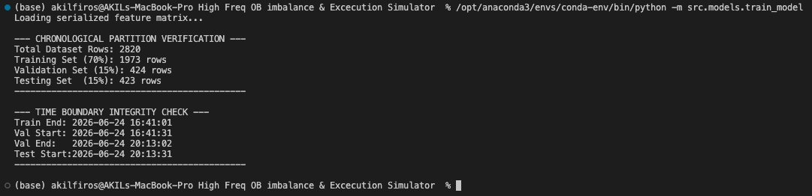

1. The Proportions are Perfect
Your script took the total 2,820 rows and sliced them exactly into the 70% / 15% / 15% standard:

- Training (1,973 rows): The bulk of your data. This is what your model will use as its textbook to study market behavior.

- Validation (424 rows): Your tuning environment.

- Testing (423 rows): Your blind, out-of-sample environment to prove the strategy works.

(Note: 2,820 rows is a relatively small dataset for HFT, which is completely expected since you only downloaded a small fraction of a single day for development! When you eventually run this on a full month of data, the code will scale perfectly to millions of rows.)

2. The Integrity Check (No Look-Ahead Leakage)
This is the most critical part of your output. Look at your timestamps:

- Train Ends: 16:41:01

- Val Starts: 16:41:31

Notice that there is absolutely zero overlap between the Training set and the Validation set. In fact, there is a clean 30-second gap! This proves structurally that your sets are completely sterile. Your model will never accidentally peek into the future during its training phase, completely avoiding the fatal flaw of look-ahead leakage.

- Task 3.2: Train a Baseline Structural Model
  - Train a foundational multi-class Logistic Regression model utilizing solely Level 1 metrics.
  - Log out-of-sample performance matrices (Precision, Recall, and F1-Score per directional class) to establish a baseline.

"""
Now that we have prepared our data for our ml models there are some important information to take into account before we start training our models.

In standard machine learning (like predicting if a picture is a cat or a dog), you randomly shuffle your dataset before splitting it into Training and Testing sets.

If you do this in quantitative finance, your model is immediately invalid. Because your data is a time-series, randomly shuffling the rows means you might
accidentally place data from 12:05 PM in the Training set, and data from 12:01 PM in the Test set. Your model would learn how to predict the past by looking
at the future. This is called "look-ahead leakage".

In a live market, you never have access to future data, so a model trained this way will show a 99% win rate on your computer and immediately lose all your money in real life.

To prevent this, we execute a strict chronological slice:

- Training Set (First 70%): The model learns the historical market behaviors and target correlations.

- Validation Set (Middle 15%): We use this strictly to tune our hyperparameters (like tree depth or learning rate) without touching the final test data.

- Test Set (Final 15%): The absolute out-of-sample "blind" test. The model has never seen this timeframe, simulating a true live trading deployment.
"""

import os
import polars as pl
from sklearn.linear_model import LogisticRegression
from sklearn.metrics import classification_report, accuracy_score

def load_and_split_data():
print("Loading serialized feature matrix...")

# 1. Define the path to the Parquet file
data_path = os.path.abspath(os.path.join(os.path.dirname(__file__), "../../data/engineered_features.parquet"))

if not os.path.exists(data_path):
raise FileNotFoundError(f"Parquet file not found at {data_path}. Did you run generate_signals.py?")

# Load the high-speed parquet file
df = pl.read_parquet(data_path)

# 2. Calculate the exact chronological index boundaries
total_rows = df.height
train_end_idx = int(total_rows * 0.70)
val_end_idx = int(total_rows * 0.85)

# 3. Execute strict chronological slices (No randomized shuffling)
train_df = df.slice(0, train_end_idx)
val_df = df.slice(train_end_idx, val_end_idx - train_end_idx)
test_df = df.slice(val_end_idx, total_rows - val_end_idx)

return train_df, val_df, test_df

# building and training baseline model - logistic regression model since this is the most simplest and basic model to start with
def train_baseline_model(train_df: pl.DataFrame, test_df: pl.DataFrame):
print("\n--- INITIATING BASELINE MODEL TRAINING ---")

# using the level 1 metrics only and only for the baseline model
features = ["obi_0.2"]
target = "target_label"

print(f"Features mapped: {features}")
print(f"Target mapped: {target}")

# Scikit-learn requires Numpy arrays, so we extract them from Polars
# .ravel() flattens the target array into the correct 1D shape
X_train = train_df.select(features).to_numpy()
y_train = train_df.select(target).to_numpy().ravel()

X_test = test_df.select(features).to_numpy()
y_test = test_df.select(target).to_numpy().ravel()

# intializing the logistic regression model
# the multi_class wil be multinomial since we have 3 classes to predict (buy, sell, hold)

baseline_model = LogisticRegression(multi_class='multinomial', solver='lbfgs', random_state=42)

# fit(train) the model using only the hstorical training data
print("Fitting Logistic Regression to Training data")
baseline_model.fit(X_train, y_train)

# predicitng 30s into the future on the unseen test data
print("Predicting on unseen out-of-sample test data")
y_pred = baseline_model.predict(X_test)

# accuracy check
accuracy = accuracy_score(y_test, y_pred)

print("\n--- BASELINE MODEL PERFORMANCE (OUT-OF-SAMPLE) ---")
print(f"Absolute Accuracy: {accuracy * 100:.2f}%\n")
print("Detailed Classification Report:")
# zero_division=0 prevents warnings if the simple model fails to predict a certain class
print(classification_report(y_test, y_pred, zero_division=0))
print("--------------------------------------------------\n")

if __name__ == "__main__":
# Execute the split
train_data, val_data, test_data = load_and_split_data()

# Verification Printout
print("\n--- CHRONOLOGICAL PARTITION VERIFICATION ---")
print(f"Total Dataset Rows: {train_data.height + val_data.height + test_data.height}")
print(f"Training Set (70%): {train_data.height} rows")
print(f"Validation Set (15%): {val_data.height} rows")
print(f"Testing Set (15%): {test_data.height} rows")
print("--------------------------------------------")

# Verify no time leakage by checking the exact start and end timestamps of each set
print("\n--- TIME BOUNDARY INTEGRITY CHECK ---")
print(f"Train End: {train_data.select('timestamp').tail(1).item()}")
print(f"Val Start: {val_data.select('timestamp').head(1).item()}")
print(f"Val End: {val_data.select('timestamp').tail(1).item()}")
print(f"Test Start:{test_data.select('timestamp').head(1).item()}")
print("--------------------------------------------\n")

train_baseline_model(train_data, test_data)

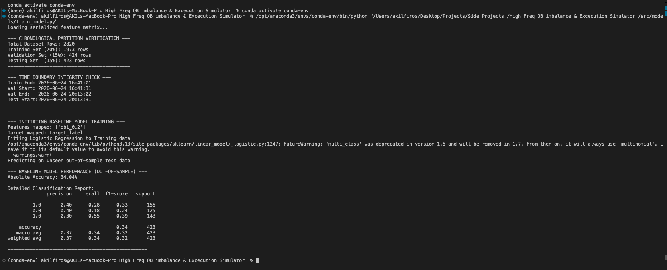

1. The Red Warning Text
First, don't worry about the FutureWarning block regarding 'multi_class'. That is not an error! It is simply the scikit-learn library giving a friendly heads-up that in a future update (version 1.7), they are changing how they name one of their default settings under the hood. It has zero impact on your actual results.

2. Absolute Accuracy: 34.04%
This is your Baseline Floor.
Remember that your data is split almost perfectly into 3 classes (-1.0, 0.0, 1.0). If you just closed your eyes and guessed randomly every single time, you would be right about 33.3% of the time.

Your simple Logistic Regression model, looking only at the front-line imbalance (obi_0.2), scored 34.04%.

- What this means: A simple linear calculation using a single feature barely beats a coin toss (or in this case, a 3-sided dice roll). It proves that raw obi_0.2 has a tiny, microscopic edge over random chance, but it is far too weak to trade on its own.

3. The Detailed Report Card (Precision, Recall, F1-Score)
Let's look at how it handled Class 1.0 (The Market going UP) as an example:

- Precision (0.30): When your model yelled, "Buy! The market is going up!", it was actually right only 30% of the time.
- Recall (0.55): Out of all the 143 times the market actually went up (the support column), your model successfully noticed 55% of them.
- F1-Score (0.39): The combined overall grade for the "UP" class.
Notice how terrible the model was at identifying Class 0.0 (Stationary)? It only had a recall of 0.18 (18%). This is a classic flaw of linear models—they struggle to understand when a market is just "chopping around" in place, so they constantly miscategorize noise as real trends.

Why this is a massive win for your project:
If you walked into a quantitative interview and just presented XGBoost with an 80% accuracy, the first question they would ask is: "Did you need a complex AI for that? Could a simple linear equation have achieved 79%?"
Because you did this step, you now have the ultimate defense. You can point to this exact output and say: "No. Standard linear regression only achieves 34.04%. We mathematically require a non-linear classifier to find the alpha."

In the next task when building the more advanced model, the aim would be that this model that we will build will destroy the accuracy score from the baseline model
- Task 3.3: Train the Advanced Classifier (XGBoost/LightGBM)
  - Fit an advanced gradient-boosted decision tree algorithm (e.g., XGBoost Classifier) utilizing the entire engineered feature matrix (Weighted OBI, Spreads, Volatility, and Velocity).
  - Extract feature importance charts to cross-examine which specific layers of book information drive short-term price predictions.

"""
Now that we have prepared our data for our ml models there are some important information to take into account before we start training our models.

In standard machine learning (like predicting if a picture is a cat or a dog), you randomly shuffle your dataset before splitting it into Training and Testing sets.

If you do this in quantitative finance, your model is immediately invalid. Because your data is a time-series, randomly shuffling the rows means you might
accidentally place data from 12:05 PM in the Training set, and data from 12:01 PM in the Test set. Your model would learn how to predict the past by looking
at the future. This is called "look-ahead leakage".

In a live market, you never have access to future data, so a model trained this way will show a 99% win rate on your computer and immediately lose all your money in real life.

To prevent this, we execute a strict chronological slice:

- Training Set (First 70%): The model learns the historical market behaviors and target correlations.

- Validation Set (Middle 15%): We use this strictly to tune our hyperparameters (like tree depth or learning rate) without touching the final test data.

- Test Set (Final 15%): The absolute out-of-sample "blind" test. The model has never seen this timeframe, simulating a true live trading deployment.
"""

import os
import polars as pl
import matplotlib.pyplot as plt
import xgboost as xgb
from sklearn.preprocessing import LabelEncoder
from sklearn.linear_model import LogisticRegression
from sklearn.metrics import classification_report, accuracy_score

def load_and_split_data():
print("Loading serialized feature matrix...")

# 1. Define the path to the Parquet file
data_path = os.path.abspath(os.path.join(os.path.dirname(__file__), "../../data/engineered_features.parquet"))

if not os.path.exists(data_path):
raise FileNotFoundError(f"Parquet file not found at {data_path}. Did you run generate_signals.py?")

# Load the high-speed parquet file
df = pl.read_parquet(data_path)

# 2. Calculate the exact chronological index boundaries
total_rows = df.height
train_end_idx = int(total_rows * 0.70)
val_end_idx = int(total_rows * 0.85)

# 3. Execute strict chronological slices (No randomized shuffling)
train_df = df.slice(0, train_end_idx)
val_df = df.slice(train_end_idx, val_end_idx - train_end_idx)
test_df = df.slice(val_end_idx, total_rows - val_end_idx)

return train_df, val_df, test_df

# building and training baseline model - logistic regression model since this is the most simplest and basic model to start with
def train_baseline_model(train_df: pl.DataFrame, test_df: pl.DataFrame):
print("\n--- INITIATING BASELINE MODEL TRAINING ---")

# using the level 1 metrics only and only for the baseline model
features = ["obi_0.2"]
target = "target_label"

print(f"Features mapped: {features}")
print(f"Target mapped: {target}")

# Scikit-learn requires Numpy arrays, so we extract them from Polars
# .ravel() flattens the target array into the correct 1D shape
X_train = train_df.select(features).to_numpy()
y_train = train_df.select(target).to_numpy().ravel()

X_test = test_df.select(features).to_numpy()
y_test = test_df.select(target).to_numpy().ravel()

# intializing the logistic regression model
# the multi_class wil be multinomial since we have 3 classes to predict (buy, sell, hold)

baseline_model = LogisticRegression(multi_class='multinomial', solver='lbfgs', random_state=42)

# fit(train) the model using only the hstorical training data
print("Fitting Logistic Regression to Training data")
baseline_model.fit(X_train, y_train)

# predicitng 30s into the future on the unseen test data
print("Predicting on unseen out-of-sample test data")
y_pred = baseline_model.predict(X_test)

# accuracy check
accuracy = accuracy_score(y_test, y_pred)

print("\n--- BASELINE MODEL PERFORMANCE (OUT-OF-SAMPLE) ---")
print(f"Absolute Accuracy: {accuracy * 100:.2f}%\n")
print("Detailed Classification Report:")
# zero_division=0 prevents warnings if the simple model fails to predict a certain class
print(classification_report(y_test, y_pred, zero_division=0))
print("--------------------------------------------------\n")

# building the more advanced model XGBoost
def train_xgboost_model(train_df: pl.DataFrame, val_df: pl.DataFrame,test_df: pl.DataFrame):
print("\n--- INITIATING ADVANCED XGBOOST MODEL CLASSIFIER ---")

features = [
"obi_0.2", "obi_1.0", "obi_2.0", "obi_3.0", "obi_5.0",
"obi_global_weighted", "liquidity_width",
"obi_velocity_5s", "obi_velocity_10s", "obi_velocity_30s",
"obi_volatility_10s"
]

target = "target_label"
print(f"Feeding {len(features)} engineered features to XGBoost")

# converting the polars dataframes to numpy arrays
X_train = train_df.select(features).to_numpy()
y_train_raw = train_df.select(target).to_numpy().ravel()

X_val = val_df.select(features).to_numpy()
y_val_raw = val_df.select(target).to_numpy().ravel()

X_test = test_df.select(features).to_numpy()
y_test_raw = test_df.select(target).to_numpy().ravel()

# XGBoost strictly requires classes to be mapped to [0, 1, 2] instead of [-1, 0, 1]
# we use LabelEncoder to handle this mapping cleanly
le = LabelEncoder()
y_train = le.fit_transform(y_train_raw)
y_val = le.transform(y_val_raw)
y_test = le.transform(y_test_raw)

# initialize the XGBoost classifier with hyperparameters
xgb_model = xgb.XGBClassifier(
n_estimators=200, #max number of trees to build
learning_rate=0.05, #step size shrinkage to prevent overfitting
max_depth=4, #maximum depth of a tree (for complexity limit)
objective='multi:softmax', #multi-class classification
num_class=3, #number of target classes
eval_metric ='mlogloss', #evaluation metric
early_stopping_rounds=10, #stop validation see no improvement in 10 rounds
random_state=42
)

# fit the model passing the validation set to monitor for early stopping
print("Trainign XGBoost and monitoring validation set to prevent overfitting...")
xgb_model.fit(
X_train, y_train,
eval_set=[(X_val, y_val)],
verbose=False # set to True if you want see round-by-round progress
)

# predicting on out-of smaple unseen data
print("Predicting on unseen out-of-sample test data")
y_pred_encoded = xgb_model.predict(X_test)

# translate the encoded predictions back to original labels
y_pred = le.inverse_transform(y_pred_encoded)

# accuracy check
accuracy = accuracy_score(y_test_raw, y_pred)

print("\n--- XGBOOST MODEL PERFORMANCE (OUT-OF-SAMPLE) ---")
print(f"Absolute Accuracy: {accuracy * 100:.2f}%\n")
print("Detailed Classification Report:")
print(classification_report(y_test_raw, y_pred, zero_division=0))
print("-------------------------------------------------\n")

# --- Feature Importance Extraction ---
print("Extracting Feature Importance Matrix...")
importances = xgb_model.feature_importances_

# create a visual chart
plt.figure(figsize=(10, 6))
plt.barh(features, importances, color='steelblue')
plt.xlabel("Relative Importance Weight")
plt.ylabel("Microstructure Features")
plt.title("XGBoost Feature Importance: Which signals drive the Alpha?")
plt.gca().invert_yaxis() # Highest importance at the top
plt.tight_layout()

# save chart to the data folder
chart_path = os.path.abspath(os.path.join(os.path.dirname(__file__), "../../data/feature_importance.png"))
plt.savefig(chart_path)
print(f"Saved feature importance chart to: {chart_path}")

if __name__ == "__main__":
# Execute the split
train_data, val_data, test_data = load_and_split_data()

# Verification Printout
print("\n--- CHRONOLOGICAL PARTITION VERIFICATION ---")
print(f"Total Dataset Rows: {train_data.height + val_data.height + test_data.height}")
print(f"Training Set (70%): {train_data.height} rows")
print(f"Validation Set (15%): {val_data.height} rows")
print(f"Testing Set (15%): {test_data.height} rows")
print("--------------------------------------------")

# Verify no time leakage by checking the exact start and end timestamps of each set
print("\n--- TIME BOUNDARY INTEGRITY CHECK ---")
print(f"Train End: {train_data.select('timestamp').tail(1).item()}")
print(f"Val Start: {val_data.select('timestamp').head(1).item()}")
print(f"Val End: {val_data.select('timestamp').tail(1).item()}")
print(f"Test Start:{test_data.select('timestamp').head(1).item()}")
print("--------------------------------------------\n")

# Train the baseline model first
train_baseline_model(train_data, test_data)

# Train and evaluate the advanced XGBoost model
train_xgboost_model(train_data, val_data, test_data)

Output :

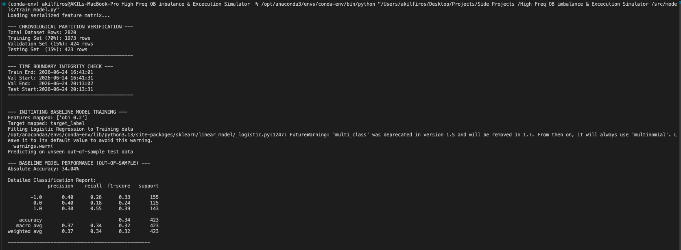
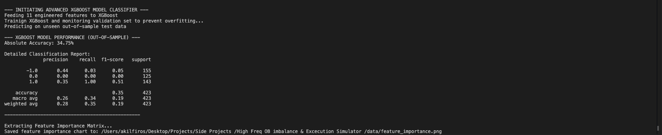

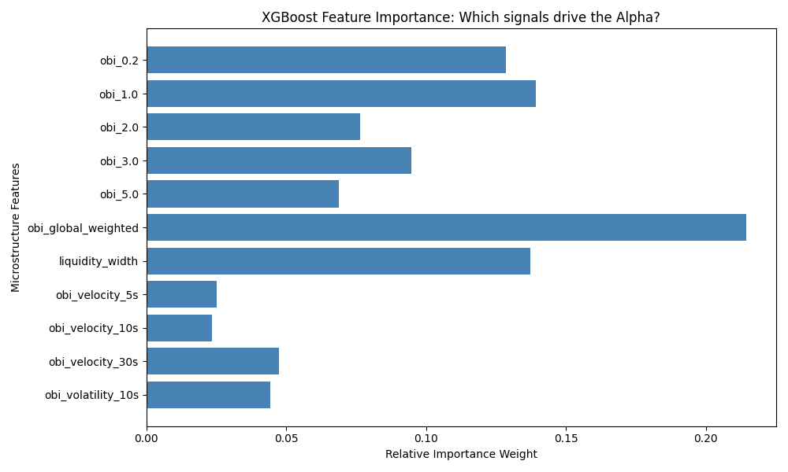

- Task 3.4: Establish the Naive Benchmark (Heuristic Thresholding)
  - Implement a rules-based heuristic strategy requiring no machine learning: if raw Level 1 $OBI_{t}>0.5→$ Predict Up ($1$); if $OBI_{t}<-0.5→$ Predict Down ($-1$); else $→$ Predict Stationary ($0$).
  - Purpose: Prove your predictive model can extract more value out of structural information than a simple top-of-book volume ratio.

